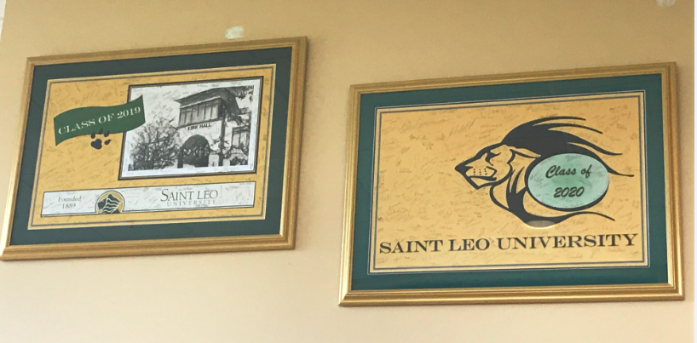

Class Gift to the President, 2019
Class Gift to the President, 2020
Artist: Karen Bryant Hannel

